RIVER WATER QUALITY MONITORING SYSTEM

A PROJECT REPORT

Submitted by

E.KEVIN FRASER (Reg.No : 2019102064)

K.LOGESH (Reg.No : 2019102066)
M.PROMOTH KUMAR (Reg.No : 2019102103)
in partial fulfillment for the award of the degree
of
BACHELOR OF ENGINEERING
in
COMPUTER SCIENCE AND ENGINEERING



SETHU INSTITUTE OF TECHNOLOGY
(An Autonomous Institution | Accredited with ‘A’ Grade by NAAC)
PULLOOR, KARIAPATTI-626 115.

ANNA UNIVERSITY: CHENNAI 600 025.

MAY 2023

SETHU INSTITUTE OF TECHNOLOGY
(An Autonomous Institution | Accredited with ‘A’ Grade by NAAC)
PULLOOR, KARIAPATTI-626 115.

ANNA UNIVERSITY: CHENNAI 600 025.

BONAFIDE CERTIFICATE

Certified that this project report entitled “RIVER WATER QUALITY MONITORING SYSTEM” is the bonafide work of “E.KEVIN FRASER”, “K.LOGESH” and “M.PROMOTH KUMAR” who carried out the project work under my supervision.

SIGNATURE SIGNATURE
Dr. M.PARVATHY Dr. B.LALITHA
HEAD OF THE DEPARTMENT SUPERVISOR

Submitted for the 19UCS804-Project Work, End Semester Examination, held on _________________

INTERNAL EXAMINER EXTERNAL EXAMINER

ACKNOWLEDGEMENTS

First we would like to thank GOD the almighty for giving us the talent and opportunity to complete our project and our B.E degree.
We wish to express our earned great fullness to our Honorable Founder and Chairman, Mr. S. Mohamed Jaleel B.Sc., B.L., for his encouragement extended us to undertake this project work.
We wish to thank and express our gratitude to our Chief Executive Officer Mr. S. M. Seeni Mohideen B.Com., M.B.A., Director-Administration, Mrs. S. M. Nilofer Fathima B.E., M.B.A., Director - R & D, Dr. S. M. Nazia Fathima B.Tech., M.E.,Ph.D and Joint chief executive officer, Mr. S. M. Seeni Mohamed Aliar Maraikkayar B.E., M.E., M.B.A.,(Ph.D) for their support in this project.
We would like to thank and express our gratitude to our Principal, Dr. A. Senthil Kumar B.E., M.E., Ph.D., for providing all necessary for the completion of the project. We wish to thank and express our gratitude to our Vice Principal, Dr. G.D.Siva Kumar B.E., M.E., Ph.D., for his support to our project work.
We wish to express our profound gratitude to our Head of the Department Dr. M.Parvathy B.E., M.E., Ph.D., for granting us the necessary permission to proceed with our project.
We are immensely grateful to our guide, supervisor and overseer Dr.B.LALITHA B.E., M.E., Ph.D., for encouraging us a lot throughout the course of the project. We render our sincere thanks of her support in completing this project successfully.
We thank our Parents, Faculty Members, Supporting Staff and Friends for their help extended during these times.

ABSTRACT
The polluted water can cause various diseases to humans and animals, which in turn affects the life cycle of the ecosystem. If water pollution is detected in an early stage, suitable measures can be taken and critical situations can be avoided. To make certain the supply of pure water, the quality of the water should be examined in real-time. In this Project, a detailed review of the latest works that were implemented in the arena of smart water pollution monitoring systems is presented. The paper proposes a cost effective and efficient IOT based smart water quality monitoring system which monitors the quality parameters uninterruptedly.

TABLE OF CONTENTS
CHAPTER NO | TITLE | PAGE NO
 | ACKNOWLEDGEMENTS | iii
 | ABSTRACT | iv
 | LIST OF FIGURES | vi
1. | INTRODUCTION | 1
 | 1.1 Definition of the Problem | 1
 | 1.2 Motivation for the Problem | 1
 | 1.3 Objective of Project | 1
 | 1.4 Usefulness/Relevance to the Society | 1
2. | LITERATURE SURVEY | 2
3. | SYSTEM ANALYSIS | 5
 | 3.1 Existing System | 5
 | 3.2 Proposed System | 5
 | 3.3 Block Diagram | 6
 | 3.4 Software and Hardware Specification | 7
4. | MODELLING OF PROJECT | 8
 | 4.1 Components of Description | 8
 | 4.2 Working of Components | 11
5. | SOFTWARE DESCRIPTION | 16
6. | HARDWARE DESCRIPTION | 23
7. | RESULT | 29
8. | CONCLUSION | 30
9. | FUTURE SCOPE | 31
10. | REFERENCE | 32
LIST OF FIGURES

FIGURE NO | FIGURE TITLE | PAGE NO
4.1.1 | IOT (WI-FI module ESP8266) | 9
5.1.1 | Pin out | 23
6.1.3  6.1.4 | Peripherals & I/O  The LED On-Board of ESP8266 | 25  26

CHAPTER 1
1.INTRODUCTION

  - DEFINITION OF PROBLEM
We reviewed out different existing system developed by researchers. Different authors have proposed distinguished models to check water quality by analyzing the parameters such as temperature, By considering all these points, we designed a smart water monitoring system which can perform all these monitoring functions.

1.2 MOTIVATION FOR THE PROJECT
The main aim is to develop a system for continuous monitoring of river water quality at remote places using wireless sensor networks with low power consumption, low-cost and high detection accuracy. PH level, etc. are the limits that are analyzed to improve the water quality.

  - OBJECTIVE OF PROJECT
IOT based River water PH monitoring system using Node MCU, Ph Sensor, Node MCU esp8266 Wi-Fi module and Cloud Application. As this is an IOT “Internet of Things” based project, the PH can be monitored from anywhere around the world.

1.4 USEFULNESS TO THE SOCIETY
Compared to the conventional water quality testing techniques, sensor based water quality testing has many advantages such as accurate, high sensitivity, good selectivity, speed, fast response, low cost etc. parameters in real time.
CHAPTER 2
LITERATURE SURVEY

1. Title: INTEGRATING MULTIPLE IRRIGATION TECHNOLOGIES FOR OVERALL IMPROVEMENT IN IRRIGATION MANAGEMENT
Author: T.A. Howell*, S.A. O’Shaughnessy, and S.R. Evett
Year: 2018
Description:
There are many tools, techniques, and/or schemes to assist producers in irrigation water management and specifically in irrigation scheduling. This paper will highlight several of those but emphasize that several methods should be used simultaneously as an improved or advanced procedure to avoid biases and to improve reliability. Water management decisions are basically strategic and tactical ones. Strategic decisions are decisions made after reviewing a season’s data (e.g. reviewing field yield maps, accounting reviews of field/farm productivity and costs to determine profits or losses) or pre-season ones like changing or modifying irrigation system methods or technology; irrigation well additions, treatment, or power selection; selecting field crop hybrids/varieties; selecting field water
management techniques; and field agronomic decisions on tillage, fertility, planting, etc. Tactical decisions for water management include the day to day ones on field to farm irrigation scheduling as well as scheduling irrigation system maintenance or emergency repairs (e.g. pipeline leaks or ruptures, irrigation well failures, power outages, etc.). Not every decision option may be necessary for either strategic or tactical options for specific operations. Figure 1 illustrates a diagrammatic flow chart for these decisions. An area of engineering or statistics is known as Decision Theory (DT).

2. Title: EVAPOTRANSPIRATION BASED IRRIGATION SCHEDULING FOR A TROPICAL FRUIT ORCHARD IN SOUTH FLORIDA

Author: Isaya Kisekka

Description:
The goal of this research was to evaluate the suitability of evapo transpiration (ET)-based irrigation scheduling technologies for agricultural applications, specifically the ability of the technologies to: apply the appropriate amount of water at the appropriate time, accurately estimate reference ET (ETO ) and maintain root zone soil water content in an optimum range (close to field capacity). To address this challenge, two studies were conducted with the following overall objectives: 1) evaluate ET-based irrigation water management in a tropical fruit orchard in south Florida and 2) compare various ETO estimation equations and spatial interpolation techniques in south Florida. The
experiment was conducted in an orchard of Akin carambola. The experiment consisted of four treatments replicated three times and arranged in a completely was based on a real-time ET irrigation schedule, T2 was based on historical ET, T3 was a standard irrigation practice (76 mm/wk) and T4 was a non irrigated treatment. Irrigation was measured using water meters, soil water tension was measured using 15 cm Irrometer tensiometers, stem water potential (Ψ) was measured using a pressure chamber and leaf gas exchanges parameters were measured using an infrared gas analyzer. ETO sent to the real-time ET controller were recorded daily and compared to onsite estimated ETO. Performance of five ETO estimation equations including: UF IFAS (1984) Penman, South Florida
, Priestley-Taylor, Turc (1961) and Hargreaves and Samani (1985) were compared against American Society of Civil Engineers-Environmental and Water Resources Institute(ASCE-EWRI) standardized ETO equation. An average of 9.9 mm d-1 of water was applied by T3 which was significantly different (P<0.0001) from the quantity of water applied by T1 (3.1 mm d -1) and T2 (2.9 mm d -1 ). T1 saved 68% of irrigation water compared to T3, while T2 saved 70%. T 1 average weekly soil water content (θ) (29%) was significantly different from θ maintained by T2 (28.1%) and T3 (28.0%). T4 (24%) θ was significantly different (P<0.0001) from all the other treatments. There were no significant differences in Ψ among all treatments. Across treatments, there was no significant different in net CO2 assimilation (A) and all treatments averaged 4.7 μmol m-2 s -1 .
ETO values sent to the real-time ET controller under estimated onsite ETO by an average of 25%. This was probably due to the fact that remote weather stations did not accurately represent onsite conditions. Results from comparison of ETO estimation equations revealed that the Turc (1961) method had the highest overall performances while Hargreaves had the lowest.

CHAPTER 3
SYSTEM ANALYSIS
3.0 INTRODUCTION
Systems analysis is a process of collecting factual data, understand the processes involved, identifying problems and recommending feasible suggestions for improving the system functioning. This involves studying the business processes, gathering operational data, understand the information flow, finding out bottlenecks and evolving solutions for overcoming the weaknesses of the system so as to achieve the organizational goals

3.1 EXISTING SYSTEM
Existing system has a mechanisms which are semi automated or manually controlled devices which are to be handled by a person responsible for monitoring for water quality. There is need to have human intervention in taking various reading of the water parameters. The instruments or tools are used either by putting/inserting a water sensing part into water and seeing the result on small display device or by directly inserting a portable device in water and watching the output on the device.

3.2 PROPOSED SYSTEM
The main aim is to develop a system for continuous monitoring of river water quality at remote places using wireless sensor networks with low power consumption, low-cost and high detection accuracy. PH, conductivity, turbidity level, etc. are the limits that are analyzed to improve the water quality. Following are the aims of idea implementation (a) To measure water parameters such as Ph, dissolved oxygen, turbidity, conductivity, etc. Using available sensors at a remote place. (b) To assemble data from various sensor nodes and send it to the base station by the wireless channel. (c) To simulate and evaluate quality parameters for quality control. (d) To send SMS to an authorized person routinely when water quality detected does not match the preset standards, so that, necessary actions can be taken.

3.2.1 ADVANTAGES

1. It will reduce the time to measure the parameters.
2. This is economically affordable for common people.
3. Water quality monitoring is used to alert us to current, ongoing and emerging problems.

3.3 BLOCK DIAGRAM

POWER SUPPLY

NODE MCU
IOT CLOUD
PH Sensor
ESP 8266
Wi-Fi Module

3.4 Hardware and Software Specifications
3.4.1 Software Specification
The software requirements document is the specification of the system. It should include both a definition and a specification of requirements. It is a set of what the system should do rather than how it should do it. The software requirements provide a basis for creating the software requirements specification.
Software Requirements:
- Arduino IDE
- Language: Embedded C
3.4.2 Hardware Specification
The hardware requirements may serve as the basis for a contract for the implementation of the system and should therefore be a complete and consistent specification of the whole system. They are used by software engineers as the starting point for the system design.
Hardware Requirements:
- Node mcu ESP8266
- PH SENSOR
- IOT Cloud
- ESP 8266
CHAPTER 4
MODELLING OF PROJECT
4.1 COMPONENTS DESCRIPTION
4.1.1 IOT (WI-FI module ESP8266)
The NodeMCU (ESP8266) is a microcontroller with an inbuilt Wi-Fi module. The total pins on this device are 30 out of which 17 are GPIO (General Purpose Input/output) pins which are connected to various sensors to receive data from the sensors and send output data to the connected devices. The NodeMCU has 128KB of RAM and 4MB flash memory storage to store programs and data. The code is dumped into the NodeMCU through USB and is stored in it. Whenever the NodeMCU receives input data from the sensors, it crosschecks the data received and stores the received data. Depending on the data received it sends a pulse to the Relay Module which in-turn acts as a switch to on or off the pump. The operating frequency of the NodeMCU ranges from 80 to 160 MHZ and the operating voltage of this device range from 3 to 3.6V. The Wi-Fi module presents in the NodeMCU range from 46 (indoors) to 92 (Outdoors) Meters.

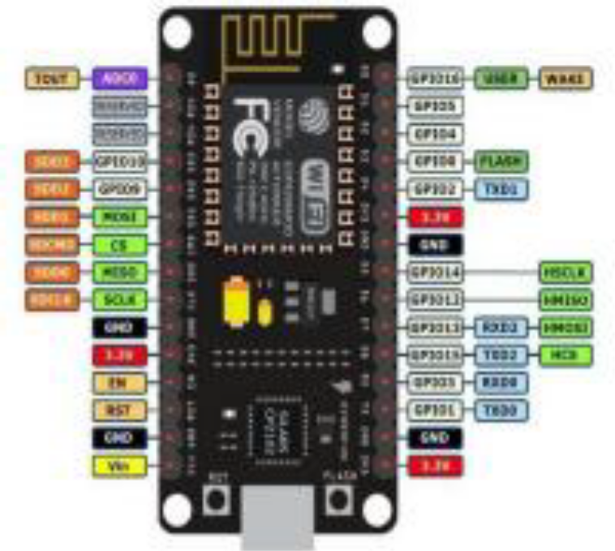
Fig 4.1.1 WI-FI module ESP8266

4.1.2 IOT Cloud
The Node MCU (ESP8266) is a microcontroller with an inbuilt Wi-Fi module. The total pins on this device are 30 out of which 17 are GPIO (General Purpose Input/output) pins which are connected to various sensors to receive data from the sensors and send output data to the connected devices. The Node MCU has 128KB of RAM and 4MB flash memory storage to store programs and data. The code is dumped into the Node MCU through USB and is stored in it. Whenever the Node MCU receives input data from the sensors, it crosschecks the data received and stores the received data.

4.1.3 PH SENSOR
PH sensor is one of the most important tools for measuring pH and is commonly used in water quality monitoring. This type of sensor is capable of measuring alkalinity and acidity in water and other solutions. When used properly, pH sensors can ensure the safety and quality of products and processes that occur in wastewater or manufacturing plants In most cases, the standard pH range is represented by a value in the range of 0-14. When a substance has a pH value of 7, this is considered neutral. pH values above 7 represent higher alkalinity, while substances with pH values below 7 are considered more acidic. For example, toothpaste usually has a pH of 8-9. On the other hand, stomach acid has a pH of 2.
The distinction between alkaline and acidic substances is important for any company that uses cooling towers, boilers, manufacturing processes, pool control and various environmental monitoring. The standard pH of the human body is 7.4, which is essential for the body to function effectively. If the body’s composition becomes too acidic or too alkaline, it will appear to revert to a neutral state.
In modern day research and industrial applications knowing the exact pH at the exact time is of paramount importance. This need is answered by various pH measurement devices which this article will later on discuss. Before going into the pH meters themselves, it is important to specify what the pH actually is.
What is measured as pH is logarithm taken from hydrogen ion concentration in moles per liter, mathematically often expressed as following:
pH = - log₁₀[H+]
It describes the acidity or alkalinity of a solution, for example used in an industrial process. Lower case letter p stands for negative base ten logarithm ad the upper case letter H stands for element hydrogen
A pH sensor is a scientific device used to accurately measure acidity and alkalinity in water and other liquid substances. It is an important device used in most industries, including power plants, pharmaceuticals, food & beverage, primaries, chemicals, oil gas, and wastewaters. Different pH sensors work differently when it comes to measuring water quality. Therefore it's essential to know the different variations, so you can be able to pick the appropriate pH applications that will satisfy your requirements. Hence, in this article, you will learn all you need to know about pH sensors.
4.2 WORKING OF COMPONENTS
4.2.1 Working of WI-FI Module
It can work as either a slave or a standalone application. If the ESP8266 Wi-Fi runs as a slave to a microcontroller host, then it can be used as a Wi-Fi adaptor to any type of microcontroller using UART or SPI. If the module is used as a standalone application, then it provides the functions of the microcontroller and Wi-Fi network.
The ESP8266 Wi-Fi module is highly integrated with RF balun, power modules, RF transmitter and receiver, analog transmitter and receiver, amplifiers, filters, digital baseband, power modules, external circuitry, and other necessary components. The ESP8266 Wi-Fi module is a microchip shown in the figure below.
A set of AT commands are needed by the microcontroller to communicate with the ESP8266 Wi-Fi module. Hence it is developed with AT commands software to allow the Arduino Wi-Fi functionalities, and also allows loading various software to design the own application on the memory and processor of the module. The processor of this module is based on the ten silica Xtensa Diamond Standard 106 micro and operates easily at 80 MHz
There are different types of ESP modules designed by third-party manufacturers. They are,
- ESP8266-01 designed with 8 pins (GPIO pins -2)
- ESP8266-02 designed with 8 pins (GPIO pins -3)
- ESP8266-03 designed with 14 pins ( GPIO pins- 7)
- ESP8266-04 designed with 14 pins (GPIO pins- 7)

The ESP8266 Wi-Fi module comes with a boot ROM of 64 KB, user data RAM of 80 KB, and instruction RAM of 32 KB. It can support 802.11 b/g/n Wi-Fi network at 2.4 GHz along with the features of I2C, SPI, I2C interfacing with DMA, and 10-bit ADC. Interfacing this module with the microcontroller can be done easily through a serial port. An external voltage converter is required only if the operating voltage exceeds 3.6 Volts. It is most widely used in robotics and IOT applications due to its low cost and compact size.

4.2.2 WORKING OF PH SENSOR
In-Situ’s pH sensors use electrical potential to measure the pH of a solution. The sensor works by comparing the electric potential of a pH-sensitive system to the potential of a stable reference system.
The sensing system uses a pH-sensitive glass bulb which changes voltage proportionally to the concentration of hydrogen ions. A sensing electrode measures the potential of the glass bulb. The sensor is filled with a potassium chloride (KCl) solution which conducts electricity between the pH-sensitive glass and the sensing electrode.
The reference system is separate from the sensing system. Instead of a pH-sensitive glass, the reference system uses a replaceable reference junction which provides electrical contact with the sample while protecting the internal system. Unlike the pH-sensitive glass, the reference junction does not change potential with changing pH. A reference electrode measures the potential of the solution. The reference system is filled with a refillable silver/silver chloride (Ag/AgCl) solution which conducts electricity between the refrence junction and the reference electrode.
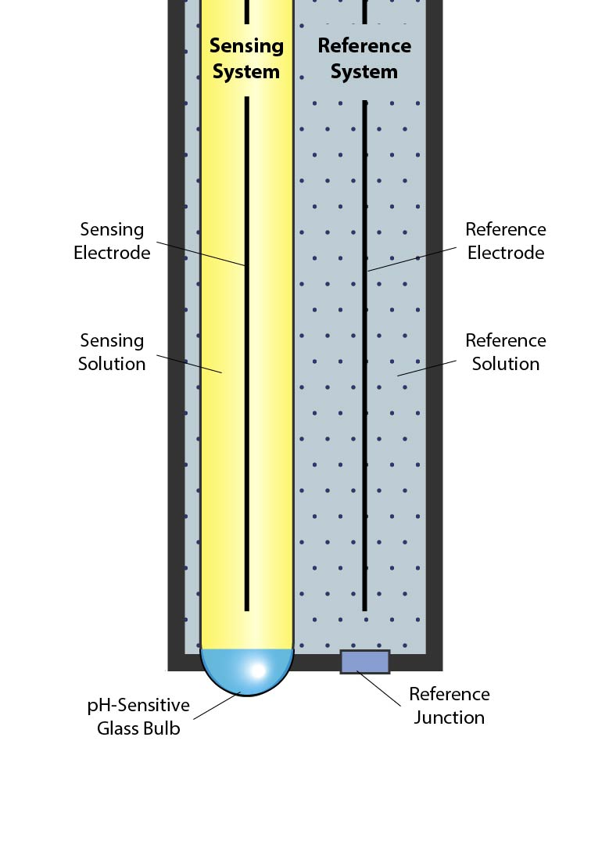
The instrument reads the signal from the pH electrode, the reference electrode, and the temperature and then calculates the pH using the Nernst equation:
E_{m} = E_{O} + (2.3RT/nF) log [H⁺]
Where:
- E_{m} is the potential from the pH electrode,
- E_{o} is related to the potential of the reference electrode,
- R is the Gas Law constant,
- F is Faraday’s constant,
- T is the temperature in Kelvin,
- n is the ionic charge (+1 for Hydrogen), and
- [H⁺] is the hydrogen ion concentration in moles/L.

CHAPTER 5
SOFTWARE DESCRIPTION
5.0 ARDUINO IDE
The arduino software (IDE) is an open source software, which is used to program the Arduino boards, and is an integrated development environment, developed by arduino.cc. Allow to write and upload code to arduino boards. And it consists of many libraries.
arduino software (IDE) is compatible with different operating systems (Windows, Linux, Mac OS X), and supports the programming languages (C/C++)
The Arduino software is easy to use for beginners, or advanced users. It uses to get started with electronics programming and robotics, and build interactive prototypes.
So Arduino software is a tool to developed new things. and create new electronic projects, by Anyone (children, hobbyists, engineers, programmers, … etc).

Arduino software interface:
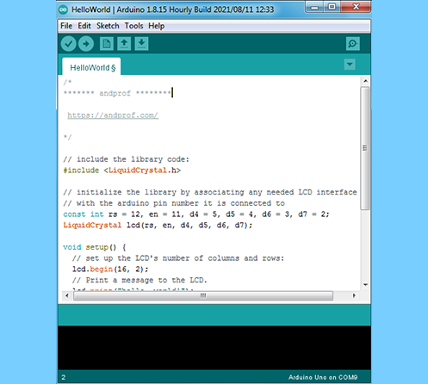

Menus section:
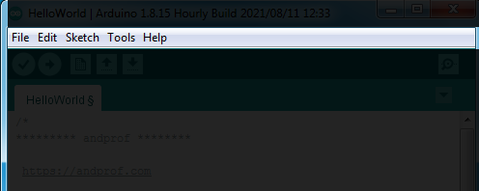
Menus are the main menus of the program, and they are 5 menus (File, Edit, Sketch, Tools, Help), and they are being used to add or modify the code that you are writing.

Toolbar section:
The toolbar is the most important section in the Arduino software, because it contains the tools that you will use continuously while programming the Arduino board. These tools are:
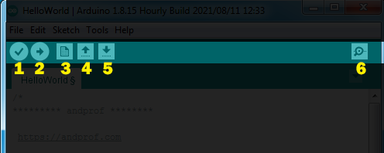
- Verify: this button use to review the code, or make sure that is free from mistakes.
- Upload: this button is use to upload the code on the arduino board.
- New: this button use to create new project, or sketch (sketch is the file of the code).
- Open: is use when you want to open the sketch from sketchbook.
- Save: save the current sketch in the sketchbook.
- Serial monitor: showing the data which have been sent from arduino.
Code editor section:
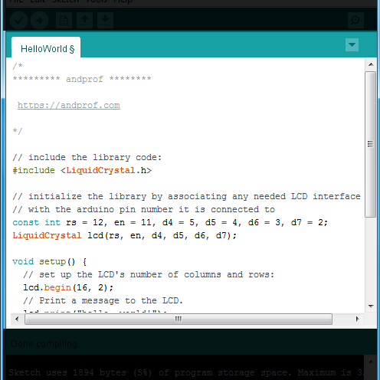
Code editor is liberator of codes, is the white space in the program, in which codes are been writing, and modifying on it.
Status bar section:
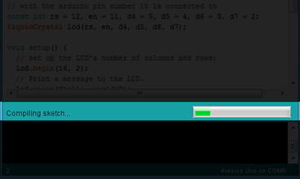

Status bar is a space can be found down the code editor, through it showing the status of operation’s completion (compiling, uploading, etc)

Program notifications section:
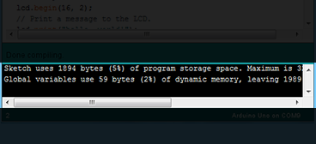
Program notifications this program showing you the mistakes of codes, and some problems that can be face you during the programmation process. And clarifies to you the type of the mistake or the problem which happened and it reason.
And it presents some instruction through it, which you have to apply to process the mistake or the problem.

Serial port & Board selections:
Serial ports selections is a space in which the program showing you the type of the port which is used to connect the arduino by computer.
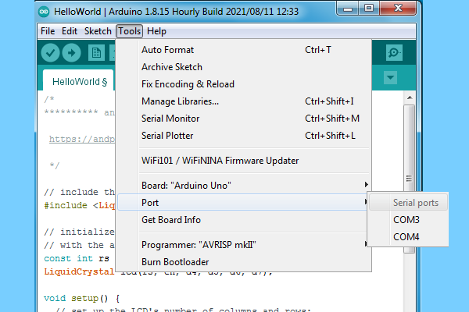

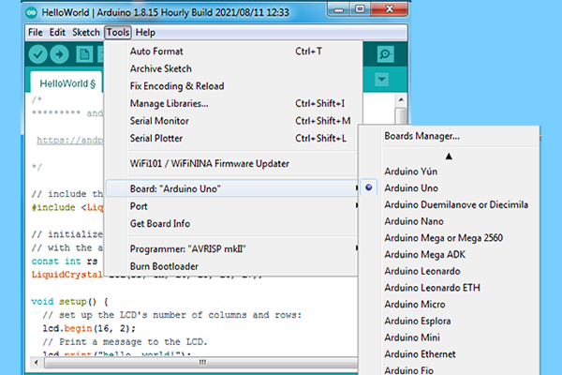

How to use Arduino software:

After installation of electronic components by using input/output pins on arduino board. We connect arduino board with computer by usb cable, and then we open arduino software.
- First thing: in the menu we click on “Tools”, then we click on “Board” and we select arduino board which you are using.
- Second: in the menu we click on “Tools” again, we click on “Port” and we select Serial port that we connected arduino board with.
- Third: in “Code editor” we write the programming code, then we click on “Verify” to verify it correctness.
- Fourth: we click on “Upload” to upload the code on the arduino board.
Thus, we have programmed the Arduino board using the Arduino program.

CHAPTER 6
HARDWARE DESCRIPTION

6.1.1 Introduction to NodeMCU ESP8266
The ESP8266 is, the name of a microcontroller designed by Expressive Systems. It is a self-contained Wi-Fi networking solution offering as a bridge from the existing microcontroller to Wi-Fi and is also capable of running self-contained applications. For less than $3, it can monitor and control things from anywhere in the world – perfect for just about any IOT project.

5.1.1 Pin out and description
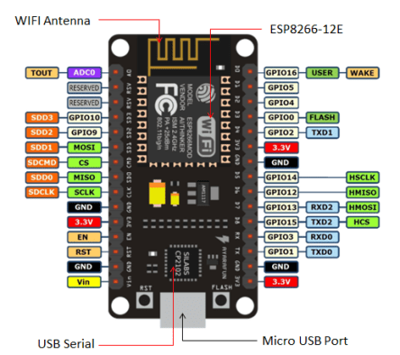
Fig 5.1.1 Pin out
The NodeMCU_ESP8266 has 30 pins in total out of which there are 17 GPIO pins. GPIO stands for General Purpose Input Output. There are the 9 digital pins ranging from D0-D8 and there is only one analog pin A0, which is a 10 bit ADC. The D0 pin can only be used to read or write data and can’t perform other options. The ESP8266 chip is enabled when the EN pin is pulled HIGH. When pulled LOW the chip works at minimum power. The board has a 2.4 GHz antenna for a long-range of network and the CP2102 is the USB to TTL converter. The development board equips the ESP-12E module containing ESP8266 chip having Ten silica Xtensa® 32-bit LX106 RISC microprocessor which operates at 80 to 160 MHz adjustable clock frequency and supports RTOS.

There’s also 128 KB RAM and 4MB of Flash memory (for program and data storage) just enough to cope with the large strings that make up web pages, JSON/XML data, and everything we throw at IOT devices nowadays. The ESP8266 Integrates 802.11b/g/n HT40 Wi-Fi transceiver, so it can not only connect to a Wi-Fi network and interact with the Internet, but it can also set up a network of its own, allowing other devices to connect directly to it. This makes the ESP8266 NodeMCU even more versatile.

6.1.2 Power Requirement
As the operating voltage range of ESP8266 is 3V to 3.6V, the board comes with an LDO (low dropout) voltage regulator to keep the voltage steady at 3.3V. It can reliably supply up to 600mA. It has three 3v3 pins along with 4 GND pins. The power supply is via the onboard MicroB USB connector. Alternatively, if you have a regulated 5V voltage source, the VIN pin is used to directly supply the ESP8266. Moreover, it requires 80mA Operating Current and 20 µA during Sleep Mode.

6.1.3 Various Peripherals and I/O
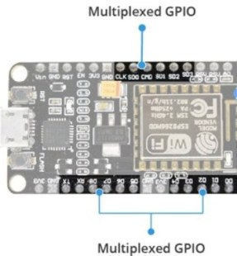
Fig 6.1.3 Peripherals & I/O
The ESP8266 supports UART, I2C, SPI communication protocols. It also has 4 PWM channels which can be used to drive motors, the brightness of the LED, etc. Moreover, there are 2 channels of the UART protocol. The ADC (A0) can be used to control any analog device. The CMD is the Chip select pin used in the SPI protocol.

6.1.4 On-Board buttons and LED
ESP8266 has 2 onboard buttons along with an on-board LED which connects with the D0 PIN. The two buttons are FLASH and RST.
- FLASH pin– It is to download new programs to the board
- RST pin – It is to reset the ESP8266 chip
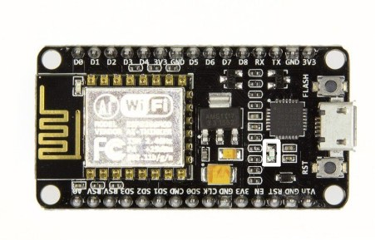
Fig 6.1.4 The LED On-board of ESP8266

8.1.5 Development Platforms
The prominent platforms include the Arduino IDE and the Explorer IDE. Other development platforms that can be equipped to program the ESP8266 are the Espruino – JavaScript SDK and firmware closely emulating Node.js, or Mongoose OS – An operating system for IOT devices.

8.1.6 Applications of ESP8266
The NodeMCU_ESP8266 is basically a WIFI module integrated with a Microcontroller, which makes it a very useful device in the field of IOT.
Its 17 GPIO pins are the prime example of this. The main use of ESP8266 is in home automation which is so much trending these days. This is due to its low power consumption in Sleep mode. Apart from it, some other examples where the ESP8266 can be used are:
- Making a web server using ESP8266
- Controlling DHT11 using the NodeMCU
- ESP8266 weather station-using BMP280
- OTA programming
- ESP8266 NTP server for fetching time

6.1.5 Nodemcu ESP8266 Specifications & Features
- Microcontroller: Ten silica 32-bit RISC CPU Xtensa LX106
- Operating Voltage: 3.3V
- Input Voltage: 7-12V
- Digital I/O Pins (DIO): 16
- Analog Input Pins (ADC): 1
- UARTs: 1
- SPIs: 1
- I2Cs: 1
- Flash Memory: 4 MB
- SRAM: 64 KB
- Clock Speed: 80 MHz
- USB-TTL based on CP2102 is included onboard, Enabling Plug n Play
- PCB Antenna
- Small Sized module to fit smartly inside your IOT projects

6.1.6 Nodemcu ESP8266 Pin out:
For practical purposes ESP8266 NodeMCU V2 and V3 boards present identical pinouts. While working on the NodeMCU based projects we are interested in the following pins.
- Power pins (3.3 V).
- Ground pins (GND).
- Analog pins (A0).
- Digital pins (D0 – D8, SD2, SD3, RX, and TX – GPIO XX)
Most ESP8266 NodeMCU boards have one input voltage pin (Vin), three power pins (3.3v), four ground pins (GND), one analog pin (A0), and several digital pins (GPIO XX).

CHAPTER 7
RESULT
We have identified a suitable implementation model that consists of different sensor devices and other modules, their functionalities are shown in figure. In this implementation model we used ATMEGA 328 with Wi-Fi module. Inbuilt ADC and Wi-Fi module connects the embedded device to internet.
After sensing the data from different sensor devices, which are placed in particular area of interest. The sensed data will be automatically sent to the web server, when a proper connection is established with sever device.

CHAPTER 8
CONCLUSION
The Presents a detailed survey on the tools and techniques employed in existing smart water quality monitoring system also a low cost less complex water quality monitoring system is proposed. The implementation enables sensor to provide online data to consumers . This can be improved by incorporating algorithms for anomaly detections in water quality.

CHAPTER 9
FUTURE SCOPE
- Detecting the more parameters for most secure purpose.
- Increase the parameters by addition of multiple sensors.
- By interfacing relay we control the supply of water.

CHAPTER 10
REFERENCES
[1] Anchit Garg, Priyamitra Munoth and Rohit Goyal, “Application of Soil Moisture Sensors in Agriculture: A Review”, Proc. Hydraulics, Vol. 21, pp. 1662-1672, 2019.
[2] [Online] Available at: http://soil quality.org.
[3] P. Sukumar, Dr. T. Kavitha, and V. Jashanavi, “Real Time soil Fertility Using IOT.”Proc.NC’s e-TIMES, 2018.
[4] J. Jayaprahas, S. Sivachandran, K. Navin, and K. Balakrishnan, “Real Time Embedded based Soil Analyzer”, Vol. 3,pp 5700-5703, 2018.
[5] Abdullah Ahmad, Ekram Khan, and WilliamIssac, “An IOT Based System For Remote Monitoring Of Soil Characteristics”, Proc. InCITe, 2019.

